Welcome to Play Football Registration at ADELAIDE VICTORY FC

Registering for Our Club

Step 1. Create a Football Account

From the 2019 Season onwards participants will no longer register using their FFA Number and instead will be able to register via their email address by creating a ‘Football Account’. The Football Account provides you with a simple way to sign in to access Football's digital channels and manage your profile from one place. Once signed up you can do the following:
  - Register as a Player, Coach, Volunteer or Referee
  - Access exclusive ticket pre-sale offers
  - Receive discounts on national teams’ tickets and finals series
  - Manage your email preferences

To Create your Football Account

- Click on the following link https://account.footballnetwork.com.au/register to Register for your Football account.
- If you are a participant be sure to use the same email address you used to register for previous seasons. This will match with the existing records within MyFootballClub and allow you to link up your history. If you do not know what this email address is please contact FFSA or FFA on the below numbers.
- Only profiles that match the email address used for your Football Account will appear as matches in the Play Football registration system.

Step 2. Register to our Club and Claim your Profile

- Once you have created a Football Account and are signed in, follow this link to proceed to the registration page:

https://registration.playfootball.com.au/common/pages/reg/WelcomeRegPlus.aspx?entityid=75810&save=0

THEN GO TO STEP 5 BELOW:

- OR go to www.playfootball.com.au and select ‘Register Now’
- Select the age group you are registering to and then enter your club name or postcode
- Select ‘Start My Registration’ on the bottom right of the page
- The below screen will appear, click on “Get Started”

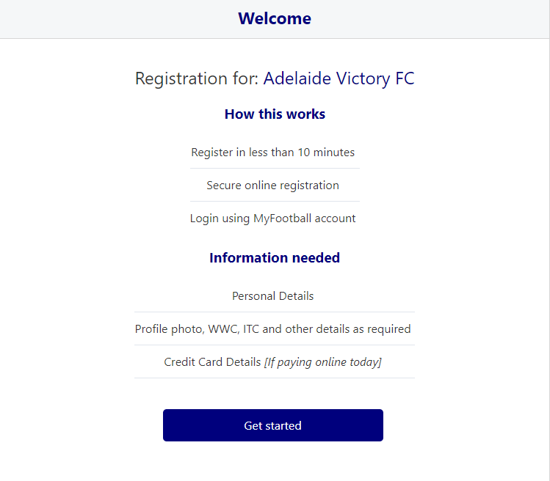

NOTE: As an existing participant logging in for the first time you will have to ‘claim’ your account details, when a participant creates a Football Account the details used to create the account will be checked to see if there are any details from MyFootballClub that match.
This will link your FFA Number to your Football Account for future registrations. If you have previously registered as a player, coach or team official and a matching FFA Number does not appear please refer to the below resources :
My Football Account does not match the email address I used for MyFootballClub. What should I do?
I do not have access to the email address used to register on MyFootballClub. What should I do?

If you are unable to resolve this and an FFA Number does not match or appear under your name, DO NOT CONTINUE, please contact the support number below immediately.
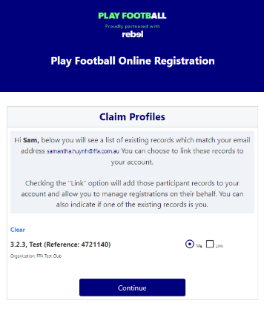

- Once you have claimed your profile you will be able to proceed with registering to our Club.
- Mini Roo Players U7 – U11 need to select Mini Roos (Aged 5 -11)
- JPL Juniors – U12 – U17 need to select Junior JPL Player (Aged 12 to 17)
- Senior Teams – U18, Reserves, Seniors need to select one of the following according to your age:
Senior Mens Player (Aged 17 & Under)
Senior Mens Player (Aged 18 & Over)
- Select the Product you are registering to and then click “Continue”
- Update your personal and contact details, and then click “Continue”
- Select Profile Image, browse from your device, and then click “Continue”
- Review your order, if you need to modify your product selection or details, select ’Modify’ in the appropriate section to do so

Acknowledging Terms and Conditions
- Click on the ‘Check box’ Read and Acknowledge all Terms and Conditions by selecting Accept All T&C’s displayed and then click “Continue”

Payment Screen
- Adelaide Victory FC will be only accepting offline payments this Season as most players have already finalised payments to the Club. You will receive an invoice from the system for the total fee to your email address. Please disregard this invoice amount as the Club will update all payments for the 2019 Season made prior to your online registration, once your registration is active on the system.
- Registration Confirmation message, select “finished” or “Perform another Registration”

For more information, please contact Sonia Ricciuto via e-mail adelaidevictoryfc@gmail.com

Once you have completed your registration you can monitor your account details, update your record, view your registration/ITC Status and Club Affiliations and register for future seasons via https://user.playfootball.com.au/

Help and Support
If you require any assistance with creating your Football Account or completing your registration, please contact the Play Football Support Centre, W: www.playfootball.com.au/help, E: playfootball.support@ffa.com.au, P: 02 8880 7983

Alternatively, contact the FFSA on 8340 3088 or info@ffsa.com.au

